Урок №
Предмет: английский язык
Дата: 8-.12 2021г.
Преподаватель: Аташева З.М.
Группа № 1-7

Тема: Глагол to be
Пройдите по ссылке изучите и законспектируйте тему, https://youtu.be/c_tVlh4--3Y затем выполните задания и вышлите на почту Zayka.atasheva@mail.ru
Таблица спряжения глагола to be
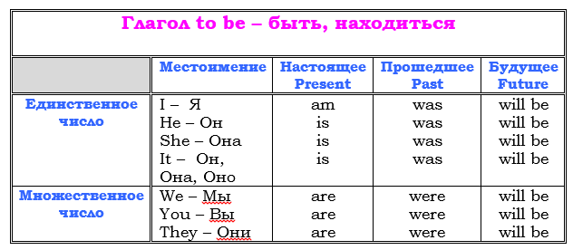
Упражнение 1 Вставить нужный глагол am, is или are.
My name (1) ______ Brenda Foster. I (2) ______ on the left in the picture. I (3) ______ ten years old and I (4) ______ in the fifth form. My birthday (5) _____ on the first of January. I (6) ______ from Santa Monica, California, USA. I (7) ______ American. My phone number (8) ______ 235-456-789. I live at 16 Park Street. My post code (9) ______ LA 30 SM. I’ve got a sister and a brother. Their names (10) ______ Gina and Paul. Gina
Упражнение 2. Write in was / were
- _________ Jenny at the party?
- _________ Lumpy quiet yesterday?
- _________ you in Kongo?
- _________ your parents in the local gym yesterday?
- _________ your friend at school yesterday?
- _________ you happy yesterday?

