**Урок №**

**Предмет: английский язык**

**Дата: 7.12 2021г.**

**Преподаватель: Аташева З.М.**

**Группа № 1-2**

**Тема: Глагол to be**

**Пройдите по ссылке изучите и законспектируйте тему,** [**https://youtu.be/c_tVlh4--3Y**](https://youtu.be/c_tVlh4--3Y) **затем выполните задания и вышлите на почту** [Zayka.atasheva@mail.ru](mailto:Zayka.atasheva@mail.ru)

Таблица спряжения глагола to be

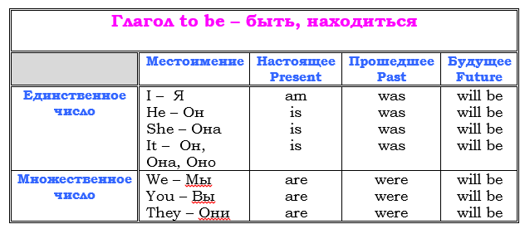

 Упражнение 1  Вставить нужный глагол ***am***,  ***is*** или ***are***.

My name (1) ______ Brenda Foster. I (2)  ______ on the left in the picture. I (3) ______  ten years old and I (4) ______ in the fifth form. My birthday (5)  _____ on the first of January. I (6) ______  from Santa Monica, California, USA. I (7) ______ American. My phone number (8) ______ 235-456-789. I live at 16 Park Street. My post code (9) ______ LA 30 SM. I’ve got a sister and a brother. Their names (10) ______ Gina and Paul. Gina

Упражнение 2. *Write in****was / were***

1. _________ Jenny at the party?
2. _________ Lumpy quiet yesterday?
3. _________ you in Kongo?
4. _________ your parents in the local gym yesterday?
5. _________ your friend at school yesterday?
6. _________ you happy yesterday?

**Урок №**

**Предмет: английский язык**

**Дата: 7.12 2021г.**

**Преподаватель: Аташева З.М.**

**Группа № 1-2**

**Тема: Глагол To have**

**Пройдите по ссылке изучите и законспектируйте тему,** [**https://youtu.be/gxA3Tsvkddc**](https://youtu.be/gxA3Tsvkddc) **затем выполните задания и вышлите на почту** [Zayka.atasheva@mail.ru](mailto:Zayka.atasheva@mail.ru)

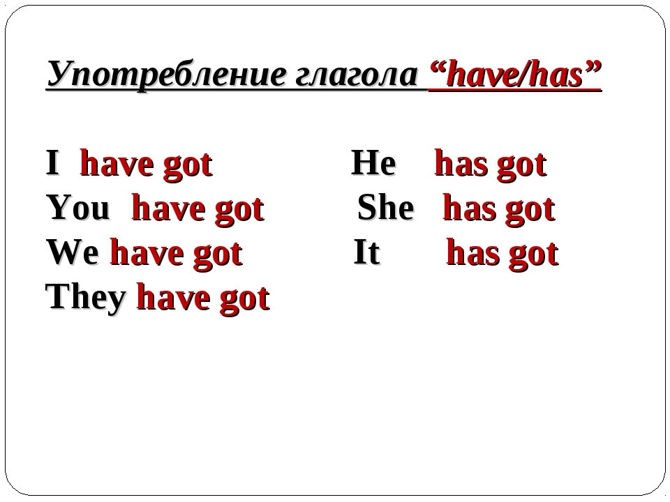

*Упражнение 1. Insert have or has.*

1. I ________ a mouse
2. You _________a mouse.
3. He_________a mouse.
4. She_________a mouse.
5. I _________ no mouse.
6. You_________ no mouse.
7. He _________ no mouse.
8. She_________no mouse.
9. It _________ a sheep.
10. We _________ a sheep.
11. You _________ a sheep.
12. They _________a sheep.
13. It _________ no sheep.
14. We _________ no sheep.
15. You_________no sheep.